Experiment Results
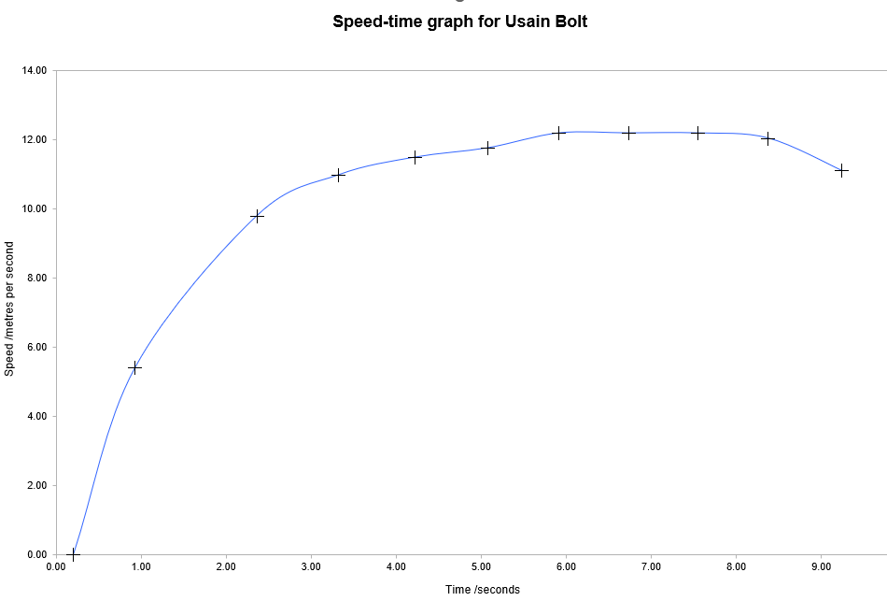
I’ve collected together some data sets for classic experiments here:

Acceleration without g
Boyles Law Experiment
Find Plank constant from LEDs
Halflife dice model
Internal resistance of 9v Cell
Inverse square law with photocell
Acceleration of a jumping popper
Mass on a spring
Energy radiated from a surface
Protactinium decay
Binding Energy
Refraction through a glass block
Speed of sound with standing waves
Usain Bolt 100m sprint world record analysis
Use Light absorption to model xray or gamma absorbtion

